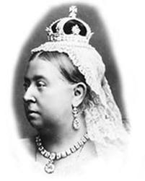
Children in Victorian Times
Queen Victoria was Queen of Great Britain from 1837 to 1901. She ruled for more than 60 years. She had nine children.

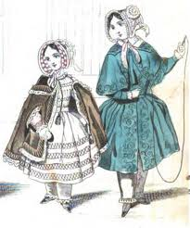
Families were very important to Victorians. They had usually five or six children sometimes more children. But life was not the same for all children during the Victorian times.
Rich people had a good and easy life. Parents of rich children were bankers, merchants or worked for the queen. They lived in beautiful, comfortable houses. Their parents organized a lot of parties. Parents had servants to do jobs at home. The children had nannies and governesses. Boys were sometimes sent to school, e.g. famous Eton school. Girls didn’t go to school but learnt to be good wives and mothers.
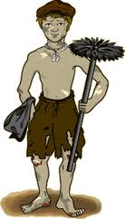
Poor people had a very hard life. Many poor children had an unhappy childhood. They had poor luxuries, ate poor food and they were often were hungry. They never went to school. They were treated like adults and began work as soon as they could walk. They worked from the age of four or five to feed themselves and their families. They worked long hours for six days a week. They did not earn much money. and in bad conditions. Their masters were often very cruel. A lot of children had health problems and accidents. Their jobs weren’t easy and were often dangerous, too.
Kinds of Jobs
Chimney sweep
Many children worked as chimney sweeps because they were small and thin. They climbed inside chimneys to clean them. The work was dangerous and painful. Street children or orphans (children who had no parents) usually did this job.
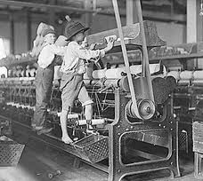
Factory worker
A lot of children also worked in cotton factories. They worked long hours, sometimes 16 hours a day! They started at 5 in the morning and finished at 9 at night. They went into machines to clean them or fix the cotton threads when they broke. They did this when the machines worked. They had many accidents then. They lost their fingers and sometimes were killed.
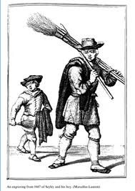
Street children
Thousands of poor children lived and worked on the streets. The streets were very dirty. They sold matches, flowers, wood, muffins, cleaned shoes or swept streets to make way for ladies and gentlemen. . Many of them were orphans. Some children stole or picked pockets to buy food and slept in the streets.

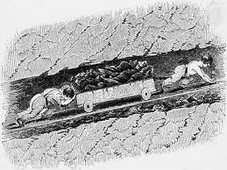

Coal Mines
Many children worked in coal mines for 12 hours a day. Some children opened and closed air doors for better ventilation. Other children pushed coal trucks.
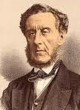

People who helped Victorian children
Lord Shaftesbury, Sir Robert Peel and Dr Barnardo wanted to protect working children by laws. They also started free schools for poor children. By the end of Victorian times, all children went to school until the age of 12.
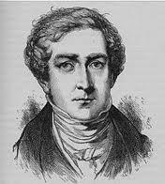
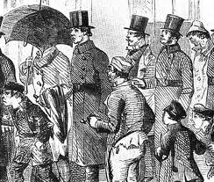

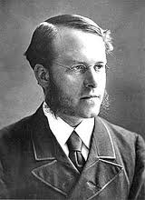

Task 1
The pictures in the text show children in Victorian times. What do you think their lives were like?
Task 2
Read the text to find out. Then answer the questions below
- How many children did Queen Victoria have?
- What was life for rich children like in Victorian times?
- What was life for poor children like in Victorian times?
- What jobs did they usually do?
- How many hours a day did they work?
- Who tried to help poor children?

Task 3
Decide if the sentences below are true (T) or false (F)
- Queen Victoria lived in the 19th century.
- Queen Victoria died when she was 60 years old.
- All children had poor life in Victorian times.
- They worked all the week.
- Orphans didn’t work at all.
- Even children as young as three had to work.

Task 4
Explain the highlighted words in the text.

Task 5
Discuss:
Should children work? Why/Why not?

